**"Speaking: Good & Ugly"**  Exercises of the pages 78 and 79

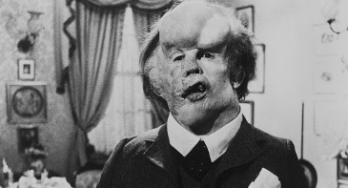**4. Match the famous “monsters” with their pictures. One of them really existed. Which one?**

The Elephant man existed. He was called Joseph Carey Merrick but as we can see, was also known as the Elephant man because of his deformations which started when he has only 18 months.

**Erik, just like the three “monsters” above suffered because of his horrible appearance. What about you?** *I can’t say if I don’t like or not the monsters because it’s indifferent but ‘the elephant man’ is a person so, you can say that he is different physically but not mentally.* **How important is a person’s physical appearance?** It depends of what you want with this person. If I find a person with ugly, with some deformity… I will not look them strange. **Talk about this with your partner, and then present your ideas to the class. Use these questions to help you.**

**1.Do you want your boyfriend or girlfriend to be attractive?**

Yes, because the stereotype that I have from a girlfriend is that she has to be pretty for my opinion and she also has to be kind, polite… and all these things

**2. How important are the clothes a person wears?**

For me it’s important because with the way you dress you can say how are you but it’s not the most important thing from a person.

**3. Do you want your friends to be attractive?**

No, it doesn’t matter for me.

**4.** **How do you react to a person who has a serious physical disability?**

First of all, it will surprise me because of the appearance but seconds later I will look him or her like I look all the other people but I want to say that the appearance almost always don’t determine the character of the person.

**5. How do you think most people in your school react?**

Most of the people would react as me but a little % of the people will laugh, thing that they will not have to do.