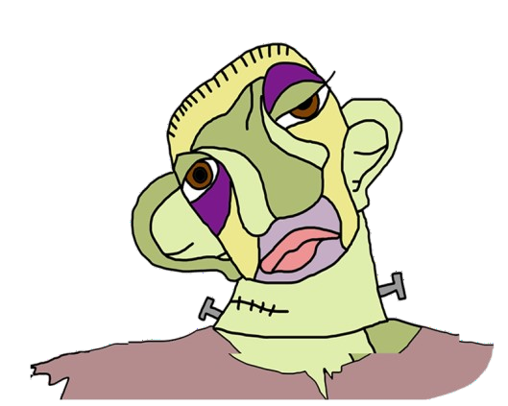MONSTERS

|  |  |  |  |
| --- | --- | --- | --- |
|  | **THE MONSTER**  **OF VICTOR FRANKENSTEIN** | **QUASIMODO** | **THE ELEPHANT MAN** |
| **REAL PERSON OR CHARACTER ?** | Character | Character | Real person |
| **WHO CREATED HIM?** | Mary Shelley | Victor Hugo |  |
| **WHEN ?** | 1st March 1818 | 1831 |  |
| **BOOK HE BELONGS TO** | Frankenstein | The Hunchback  of Notre-Dame |  |
| **HIS PROBLEM** | The monster hates Frankenstein for abandoning him. | He was abandoned for his mother. He has a kind heart. | He was born with some deformities. |
| **COULD HE BE HAPPY?** | No, because she feels lonely. | Yes, but not all the story. | When his mother dead he starts feeling unhappy. |
| **HOW DID HIS LIFE END?** | He did not like the things he did and took his own life. He commit suicide. | He dies. | He dies. |